

AUTOSAR Studio Desktop

Ain Shams Unvirsity

Graduation Project

2018

1- AUTOSAR Studio Overview

2- What have been Done

3- Setup

4- Snapshots

5- What ‘s next

**1- AUTOSAR Studio Overview**

AUTOSAR Studio Project is written with Web Technologies (HTML,CSS,JavaScript) and also electron framework to make it as Desktop Application

The aim of the software is to Design Software Components Model and Change it to ARXML files (SWCs.ARXML ,DataTypesAndInterface.ARXML,…..)

SWC1.ARXML

SWC2.ARXML

Composition.ARXML

DataTypesAndInterfaces.ARXML

…….

ARXML

Generator

SWC1.ARXML

SWC2.ARXML

......

**2- What have been Done**

* The main user Interface
  + Intro Window
  + Software components Diagram
  + Connect the tool to local database
  + Generate DataTypeAndInterface ARXML File
  + Generate software component ARML File (not all tags yet)

**3- Setup**

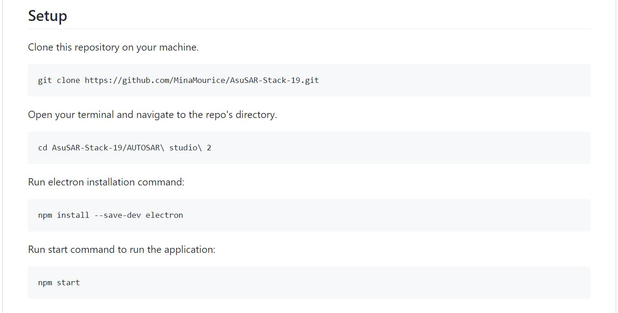

**4- Snapshots**

1. Creating Project
   1. Click on create project button

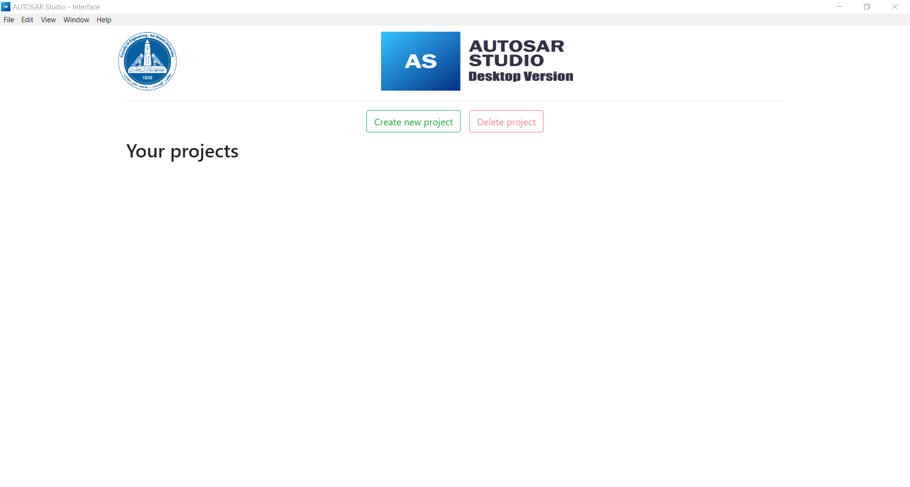

* 1. Write the project name

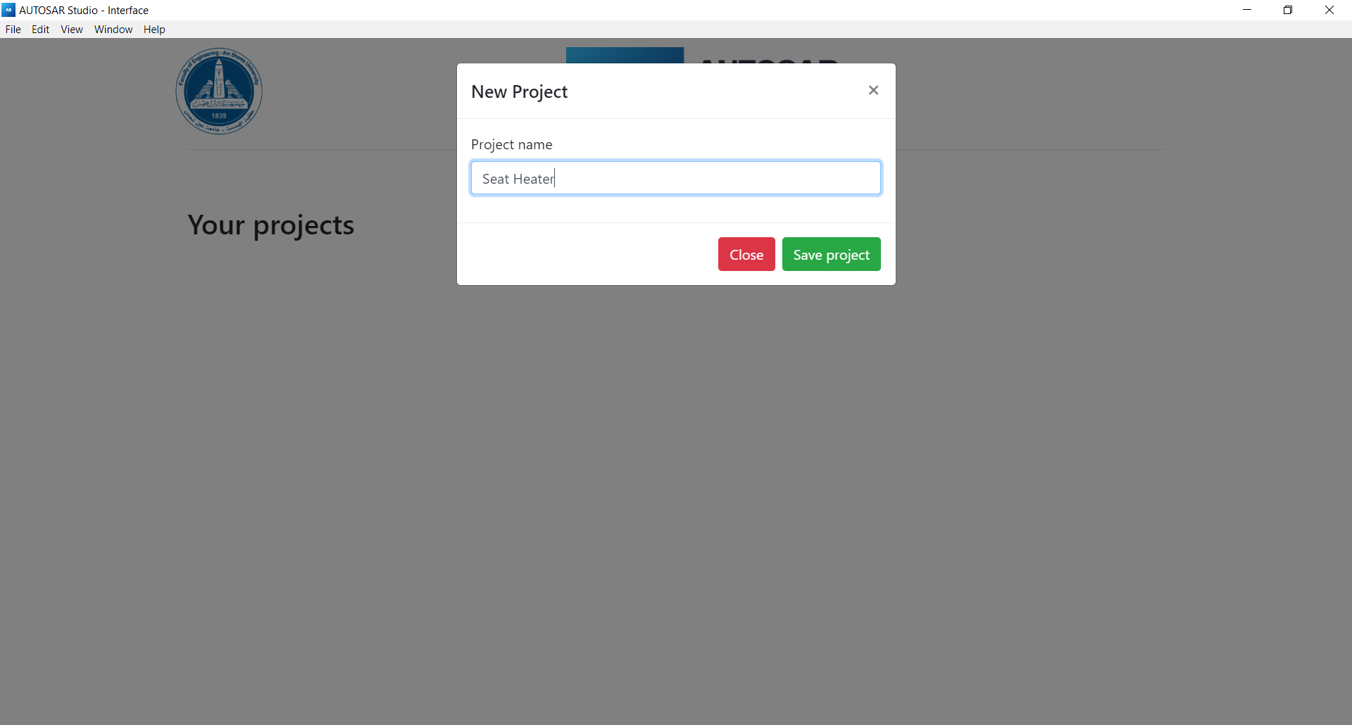

2- Create a software component

1. Choose your project you want to edit

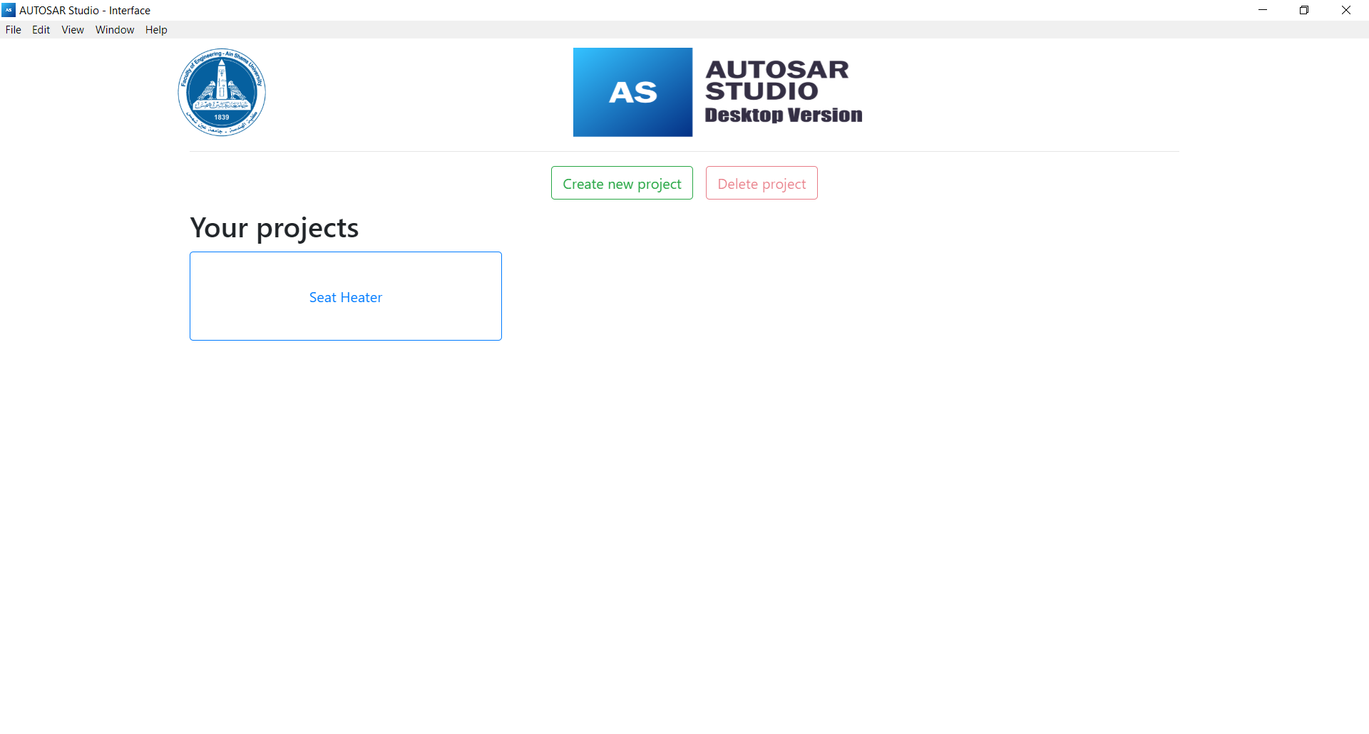

b- To create new software component by double click left mouse button then enter software component name then press save button

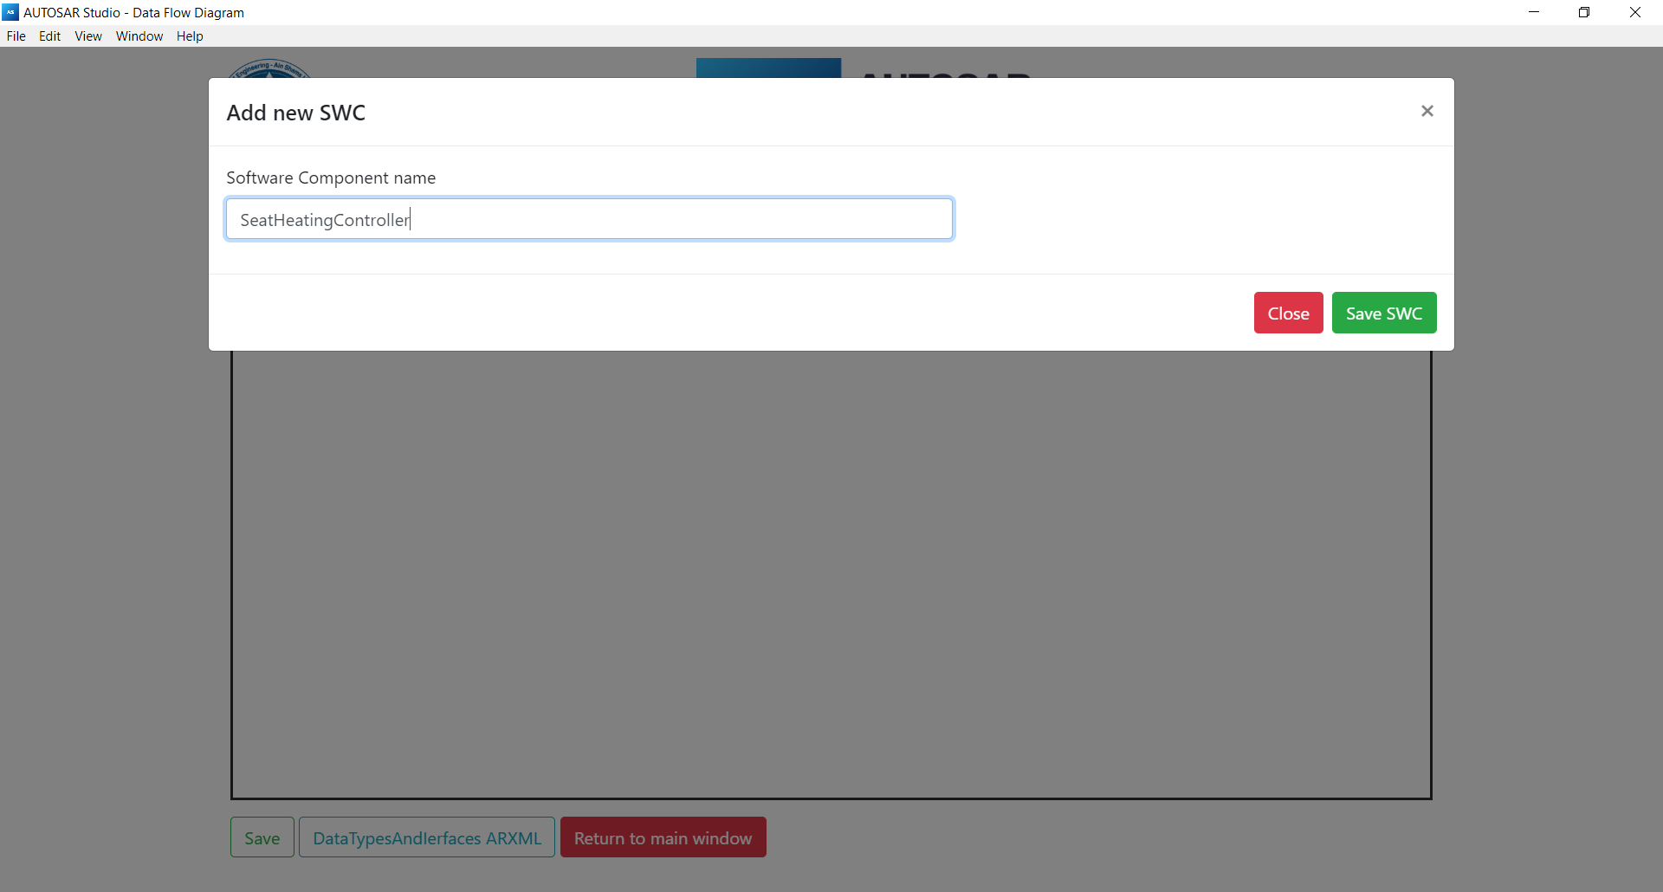

3- Add a new port

1. Right click on the software component you want to add a new port

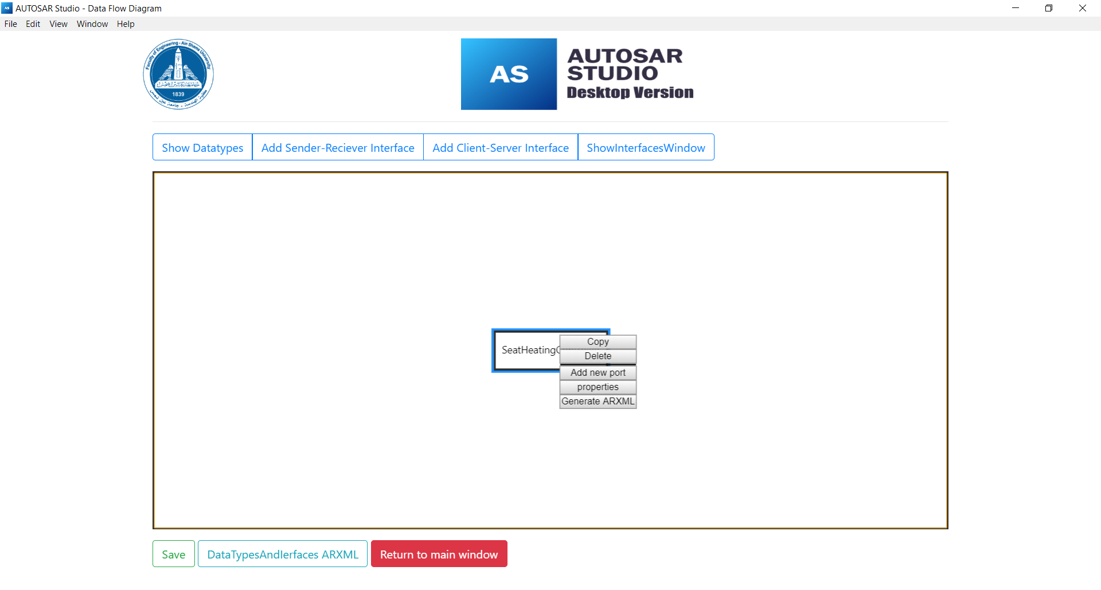

1. Enter port name and choose it’s type

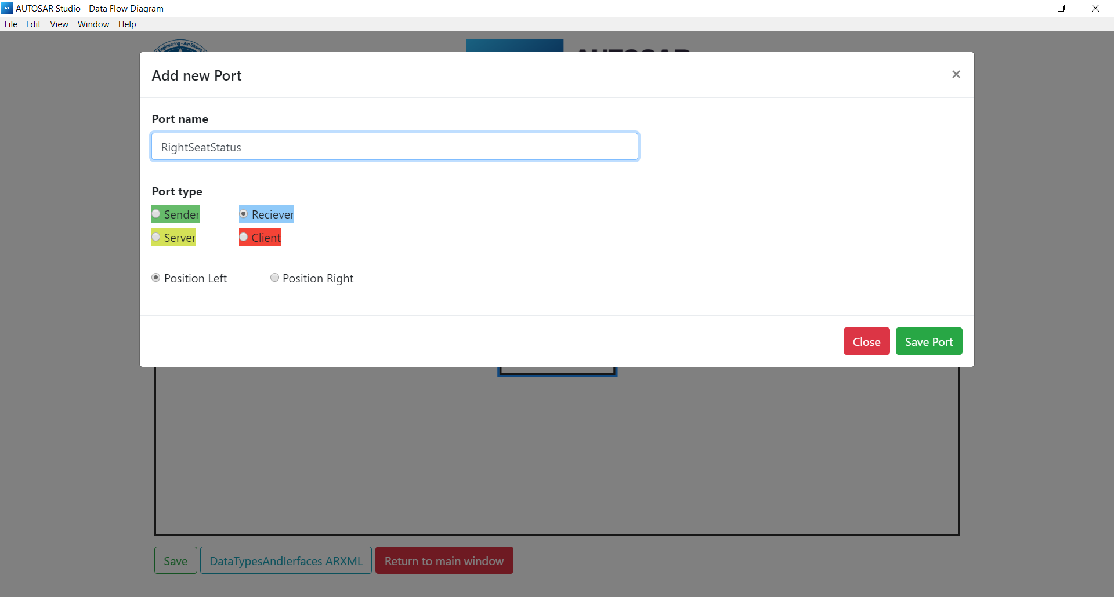

4- Show Datatypes

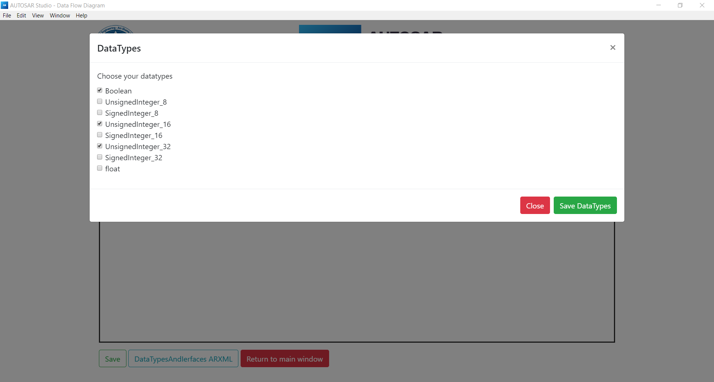

5- Add sender-reciever interface

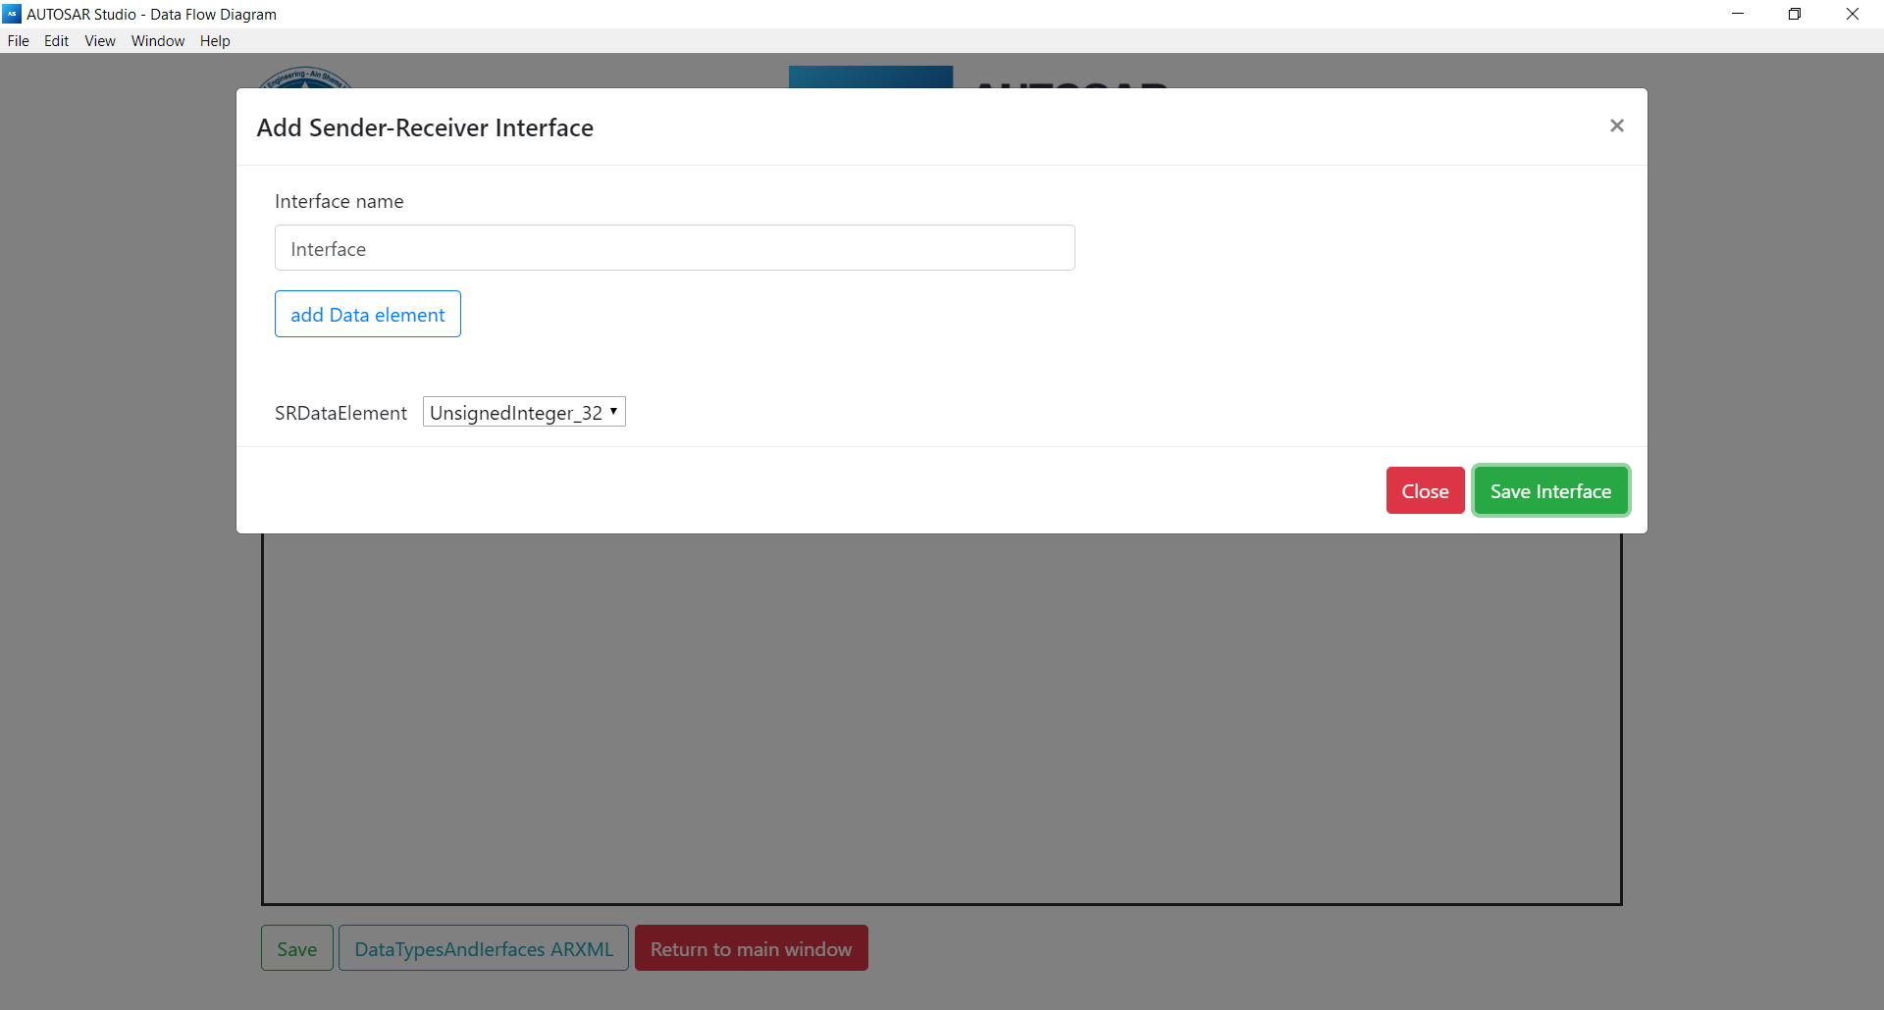

6- Add client-server interface

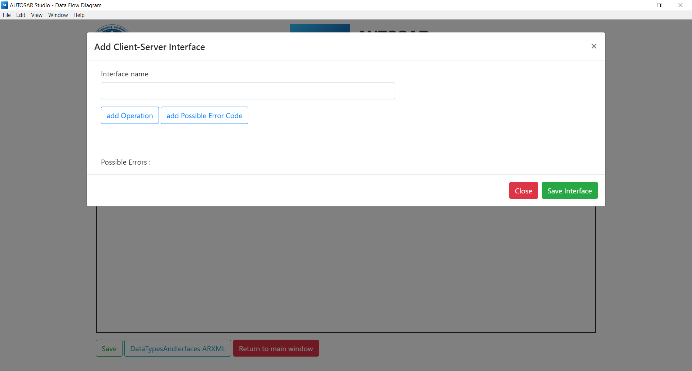

7- Edit Software Component Properties

(Ports , Runnables , Events)

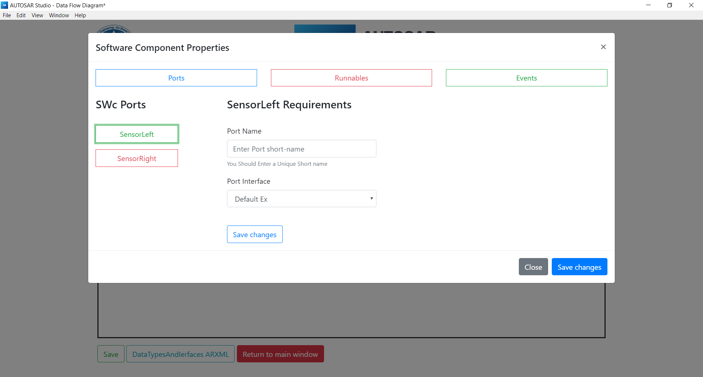

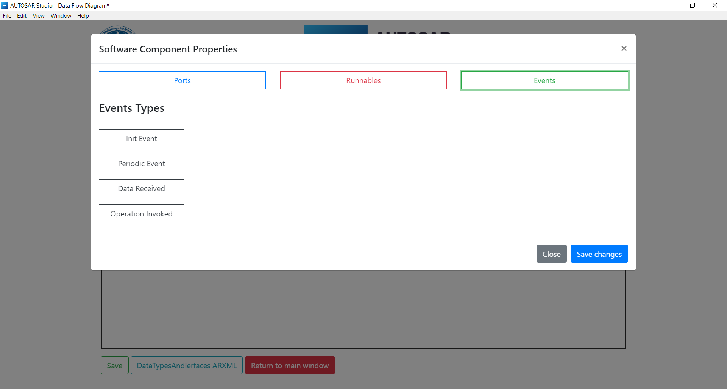

**5- What’s next**

- Complete Software component runnable creation

- Generate complete software component ARXML file